Tools

Lüdecke Armaturen GmbH

92224 Amberg Tel.(0049) 09621 76820
Heinrich-Hauck-Str. 2 Fax (0049) 09621 768299
www.luedecke.de
info@luedecke.de

Low-pressure hose crimping machine Type No. SPR-333

With the help of this crimping machine low-pressure hose lines from 3 to 16 mm can be assembled fast and cost-saving.

You can find a large variety of suitable fittings and ferrules in our main catalogue.
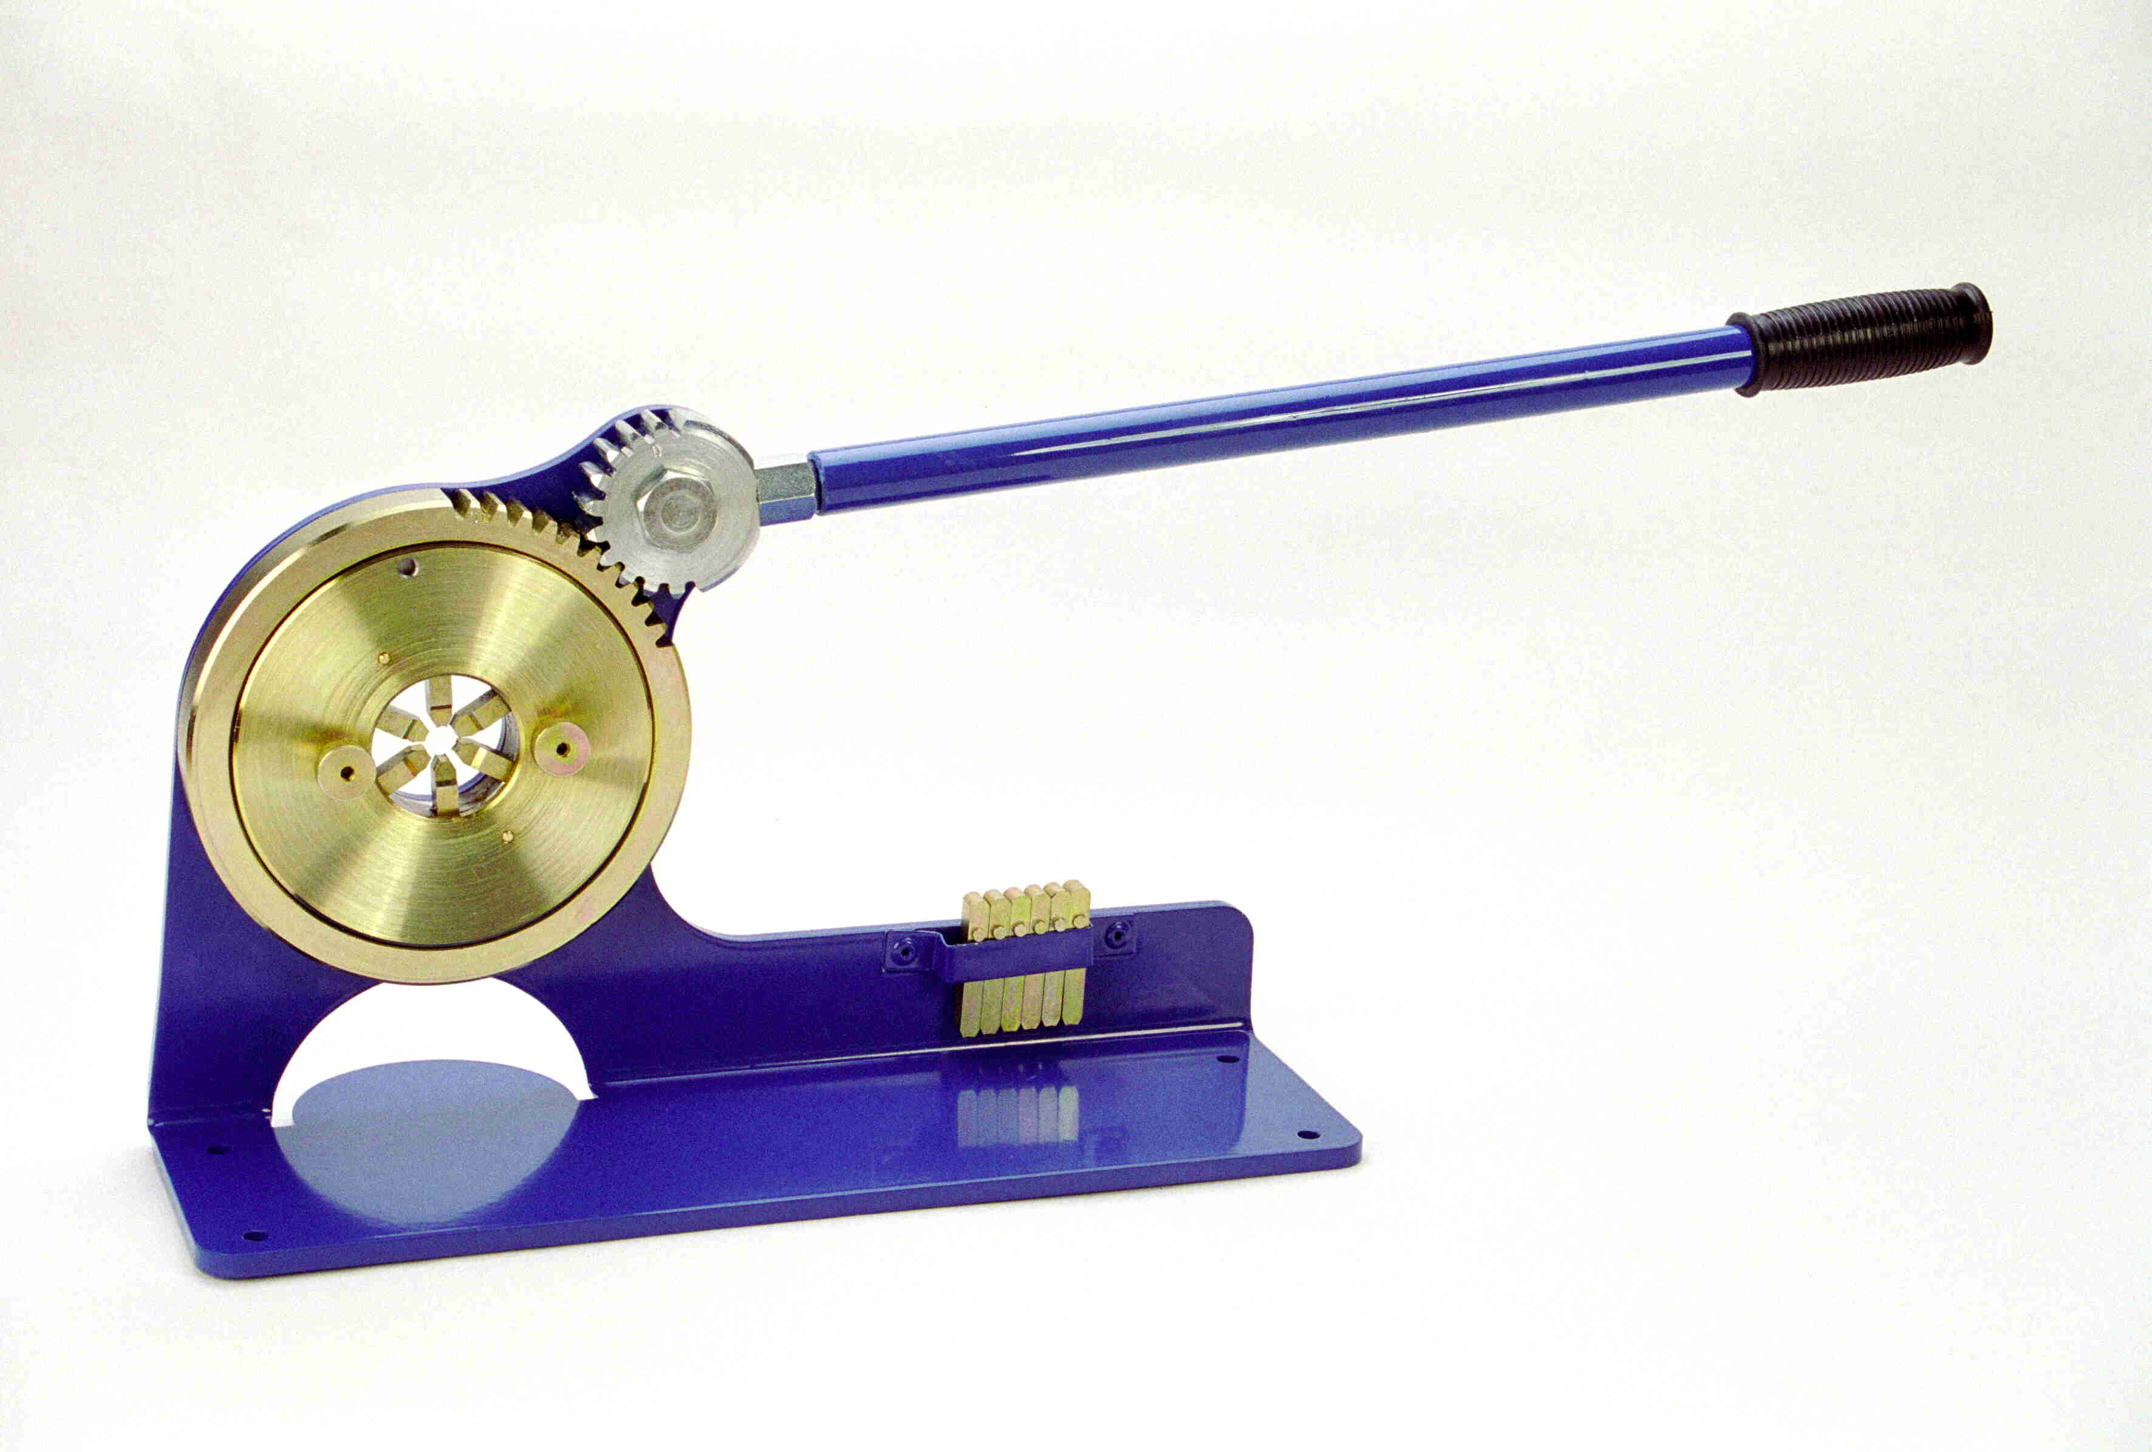

Instruction Manual

Before using the crimping machine, it has to be fixed with four screws on a suitable support.

The hose, assembled with ferrule and fitting, is put into the machine’s hole from left or right.
When the handle is pressed down, the ferrule is crimped equally and densely by the six crimping jaws.
The pressing has to be effected by crimping the ferrule in the first third, leaving a small fringe up front.

Please use the jaw set with the smaller ends for hoses of nominal size 3 – 8 mm, and the jaw set with wider ends for hoses of nominal size 10 – 16 mm.

To change the jaws you have to put the handle in the upper position. Remove the cover plate of the press by opening the knurled screws, and take out the jaws.
When reassembling the machine please make sure that all jaw endings touch the curved piece and that the pin at the top of the curved piece matches the hole in the return slice as well as the hole in the cover plate. All crimping jaws should move properly in their channels.

